Nama : Ikhwan Fahmi

NIM : L200170174

Kelas : F

Tabel_NilaiUjian

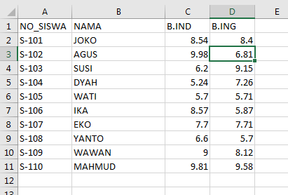

Design- Proses

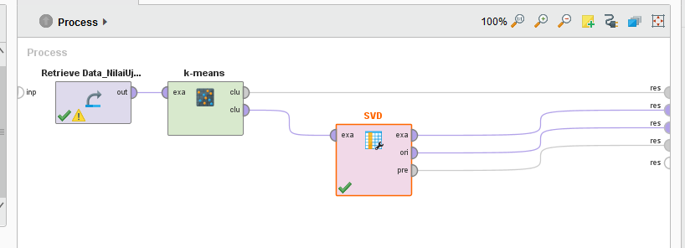

SVD

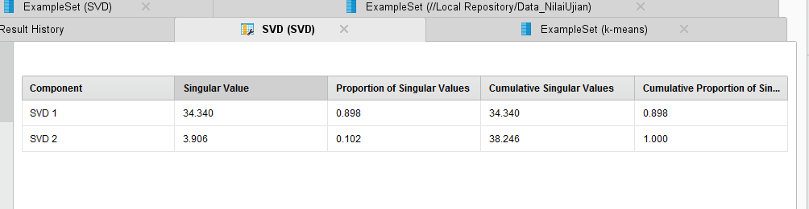

Example Set (Data_NilaiUjian)

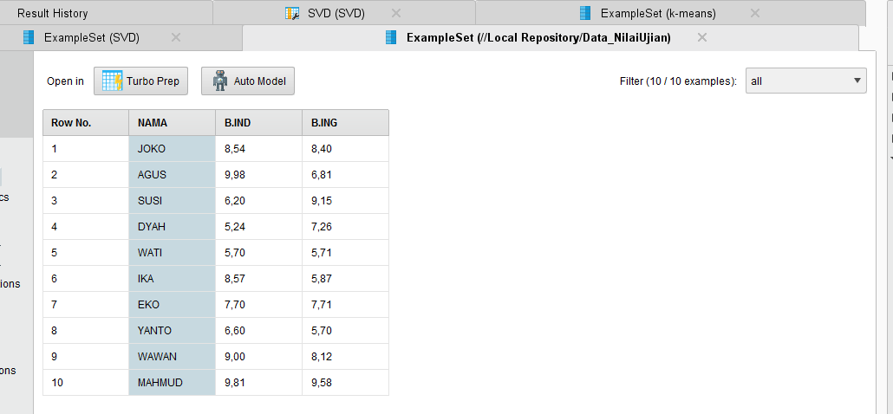

Example Set k-means

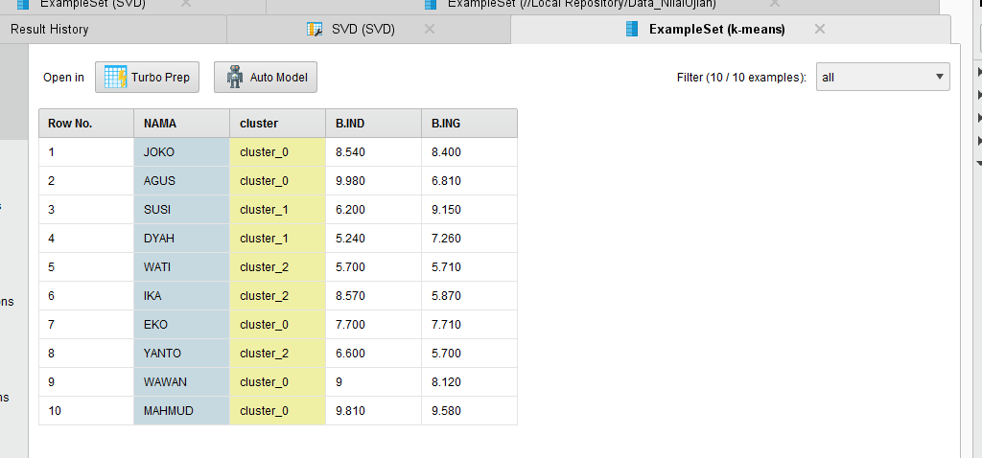

Example Set SVD

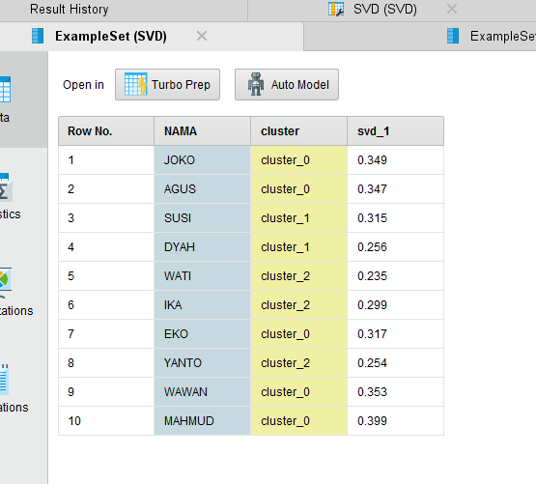

SVD Vector

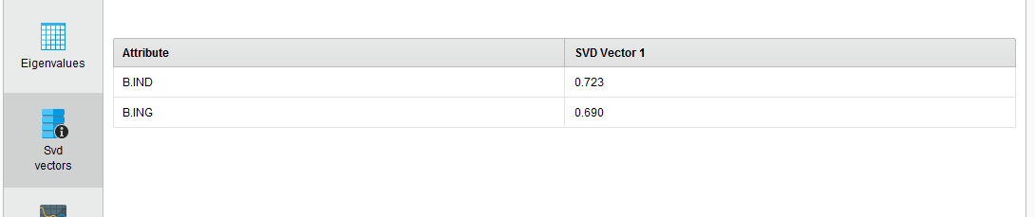

Comulative Variance

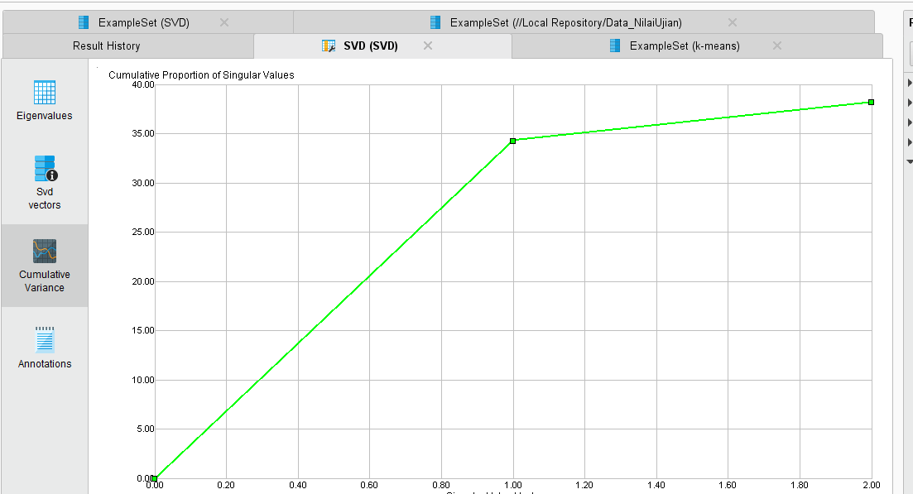

Example Set (k-means) – Plot view (Bhs Indo)

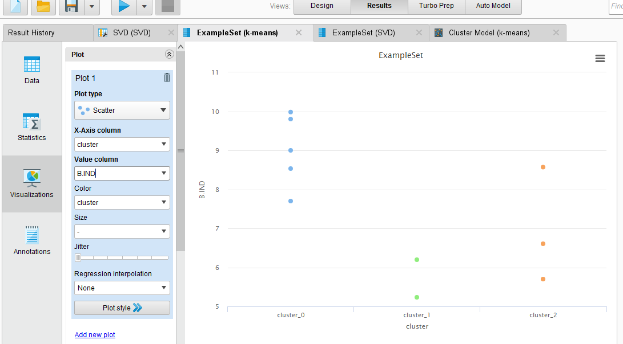

Example Set (k-means) – Plot view (Bhs Inggris)

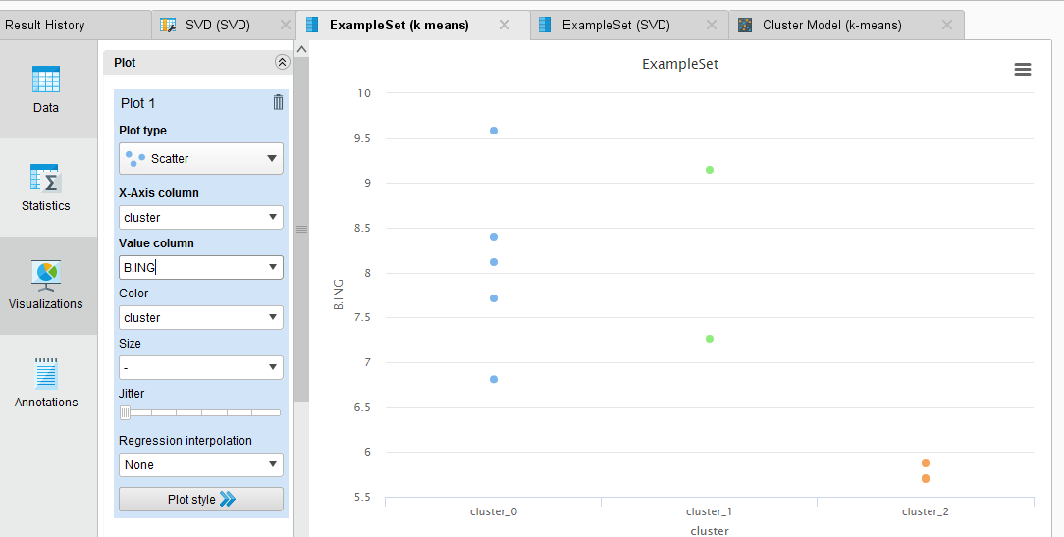

Example Set (SVD)

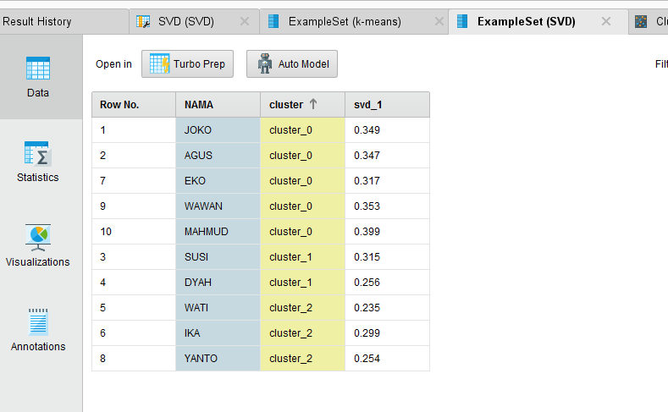

Cluster Model (Clustering)

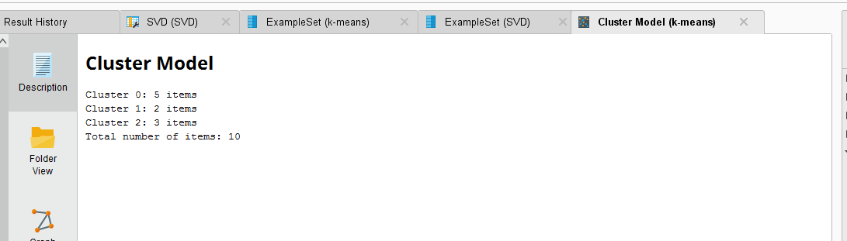

Graph

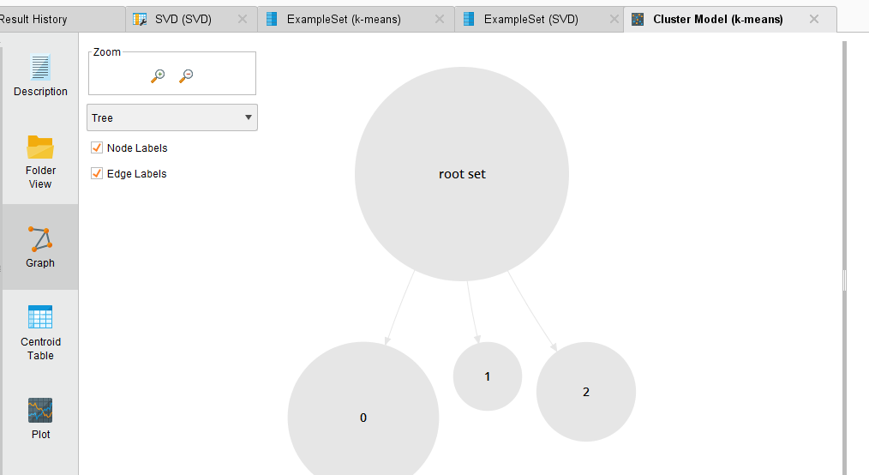

Interpretasi Hasil Argoritma k-means

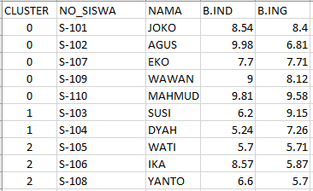

Tugas

1. Tabel di Microsoft Excel

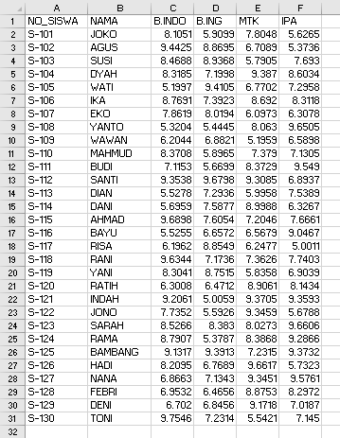

1. Lakukan Kegiatan 10.4.1 dan 10.4.2

Design - Proses

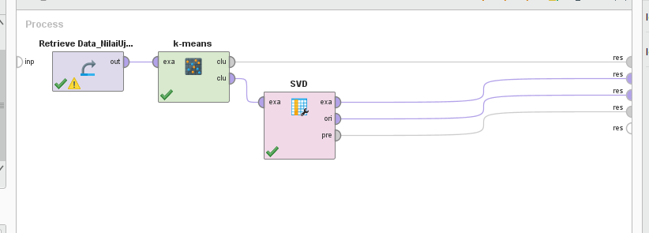

1. SVD
2. Nilai Eigenvalue

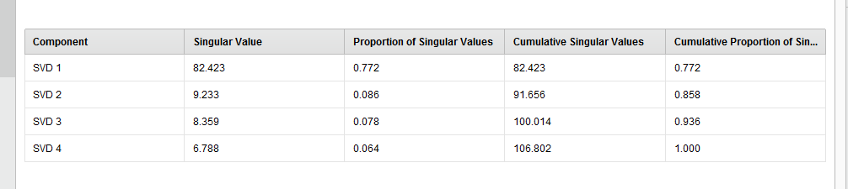

1. Nilai svd vectors

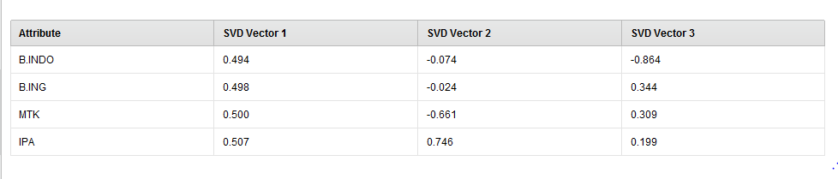

1. Nilai Cumulative variance

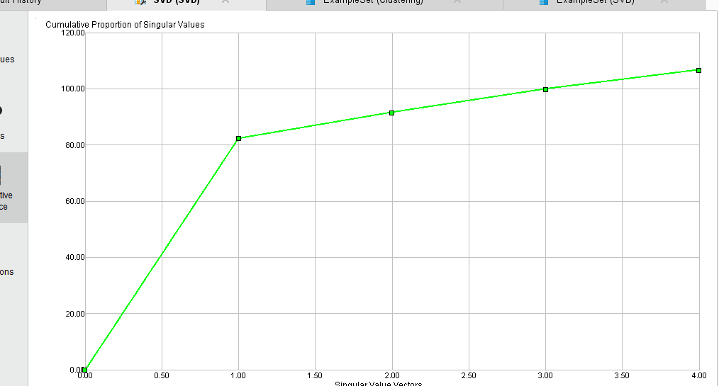

1. Example Set (k-means)

Bhs Indo

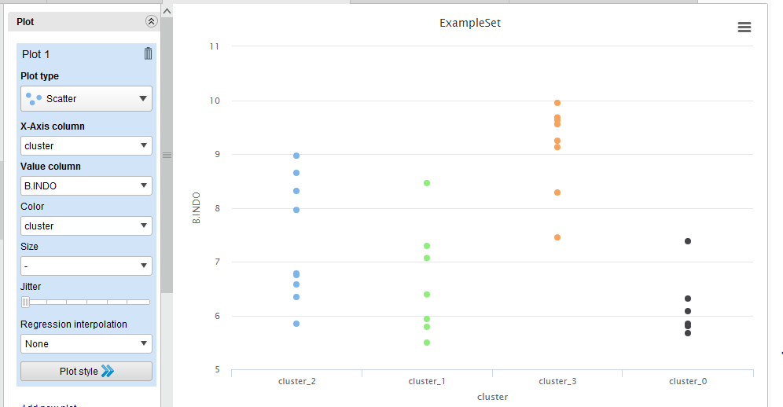

Bhs Ing

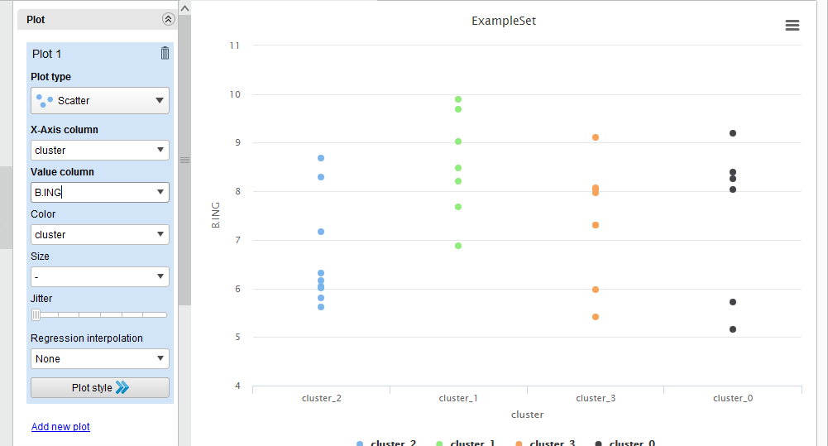

MTK

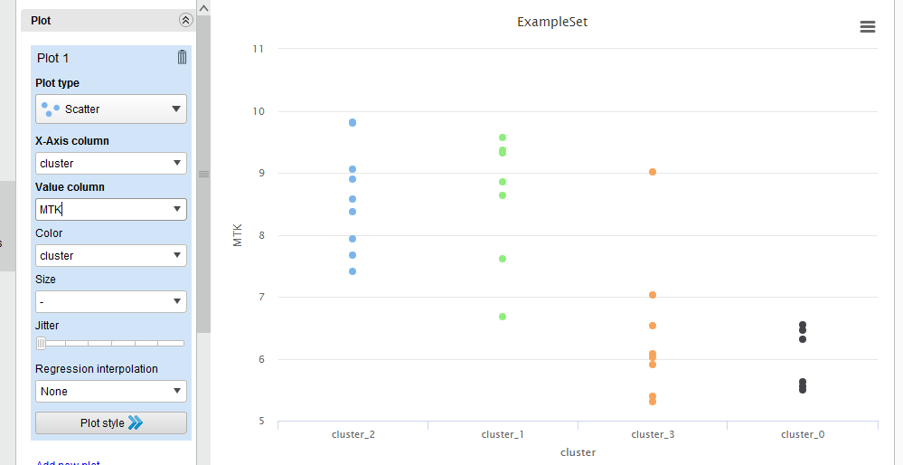

IPA

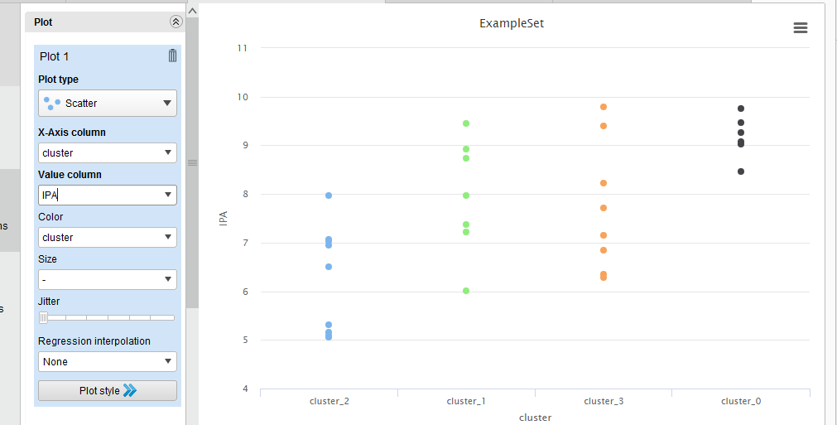

ExampleSet SVD

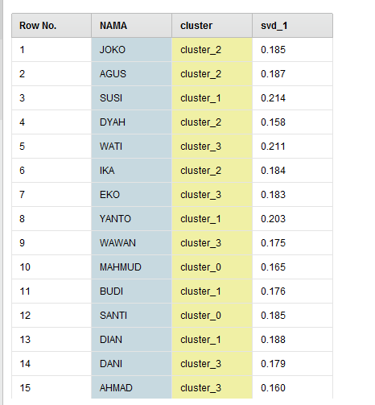

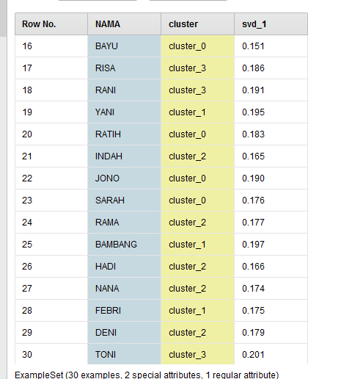

Cluster Model

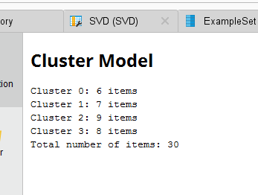

Graph

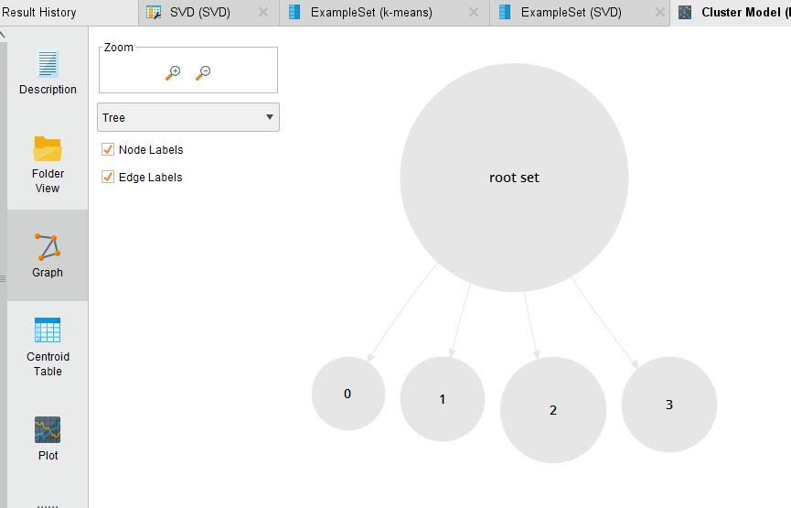

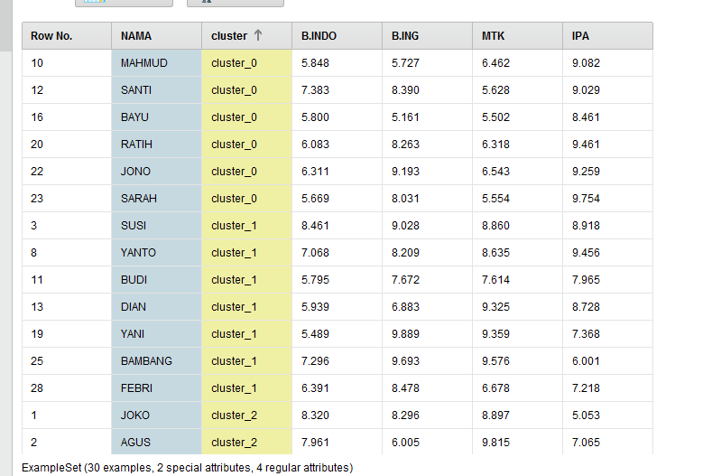

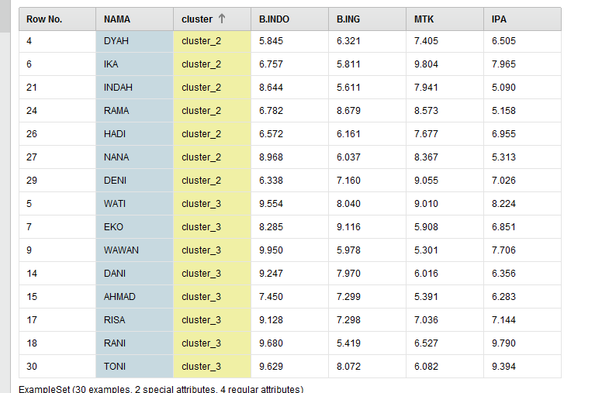

Interpretasi Hasil Algoritma k-means

